One-Pot Synthesis of Novel 2,3-Dihydro-1H-indazoles
Gary W. Breton * and Antonio J. Lepore
Department of Chemistry, Berry College, Mount Berry, GA 30149, USA
Supplementary Materials
1. ¹H-NMR spectrum of 1,2-di-tert-butyl 5-methyl-1H-indazole-1,2-(3H)-dicarboxylate (10b)
2. ¹³C-NMR spectrum of 1,2-di-tert-butyl 5-methyl-1H-indazole-1,2-(3H)-dicarboxylate (10b)
3. ¹H-NMR spectrum of 1,2-di-tert-butyl 5,6-dimethyl-1H-indazole-1,2-(3H)-dicarboxylate (10d)
4. ¹³C-NMR spectrum of 1,2-di-tert-butyl 5,6-dimethyl-1H-indazole-1,2-(3H)-dicarboxylate (10d)
5. ¹H-NMR spectrum of 1,2-di-tert-butyl 5,6-dimethoxy-1H-indazole-1,2-(3H)-dicarboxylate (10e)
6. ¹³C-NMR spectrum of 1,2-di-tert-butyl 5,6-dimethoxy-1H-indazole-1,2-(3H)-dicarboxylate (10e)

7. ¹H NMR spectrum of 1,2-di-tert-butyl 5-methyl-1H-indazole-1,2-(3H)-dicarboxylate (10b)
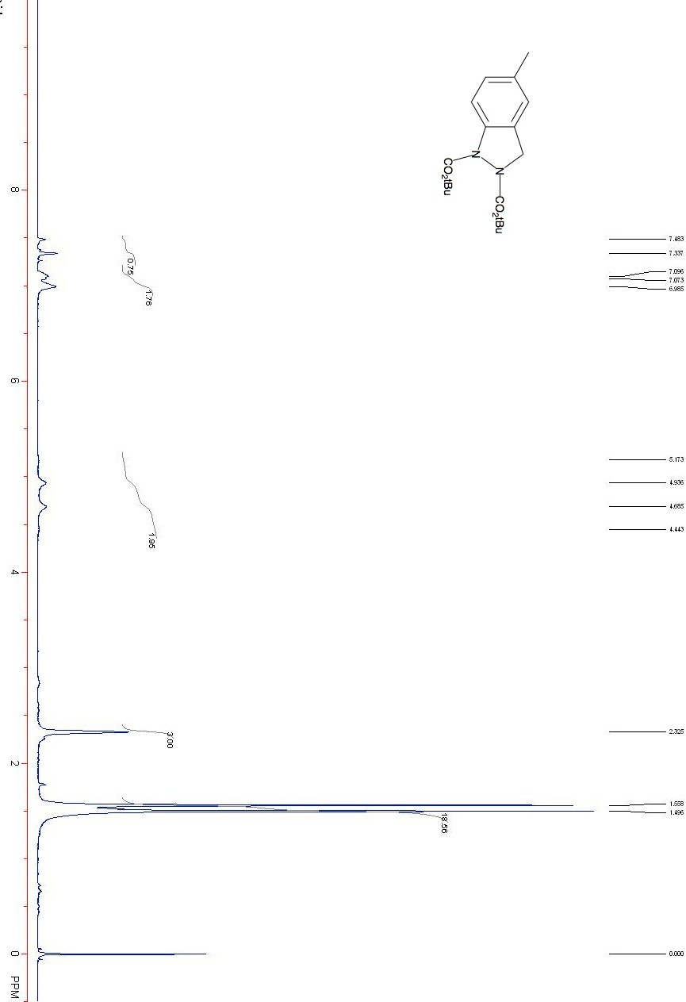

8. ¹³C NMR spectrum of 1,2-di-tert-butyl 5-methyl-1H-indazole-1,2-(3H)-dicarboxylate (10b)
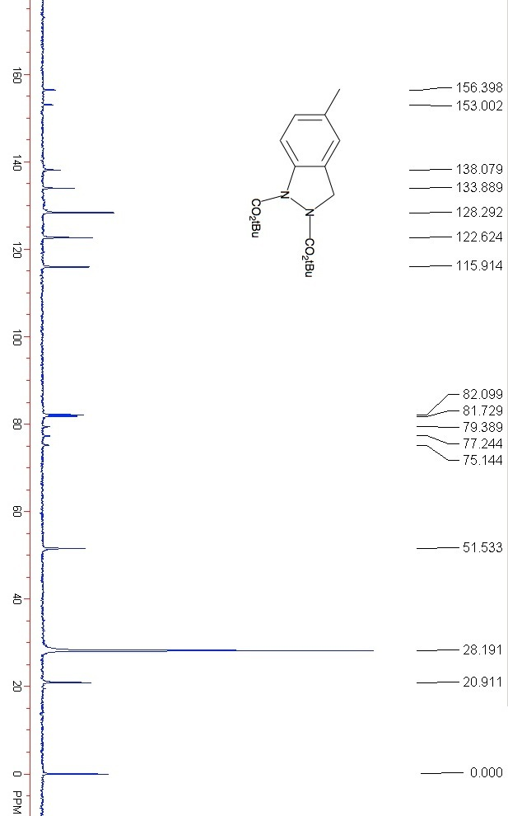

9. ¹H NMR spectrum of 1,2-di-tert-butyl 5,6-dimethyl-1H-indazole-1,2-(3H)-dicarboxylate (10d)
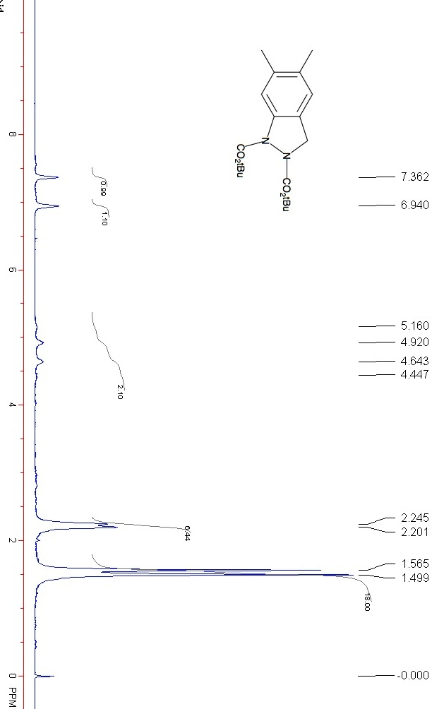

10. ¹³C NMR spectrum of 1,2-di-tert-butyl 5,6-dimethyl-1H-indazole-1,2-(3H)-dicarboxylate (10d)
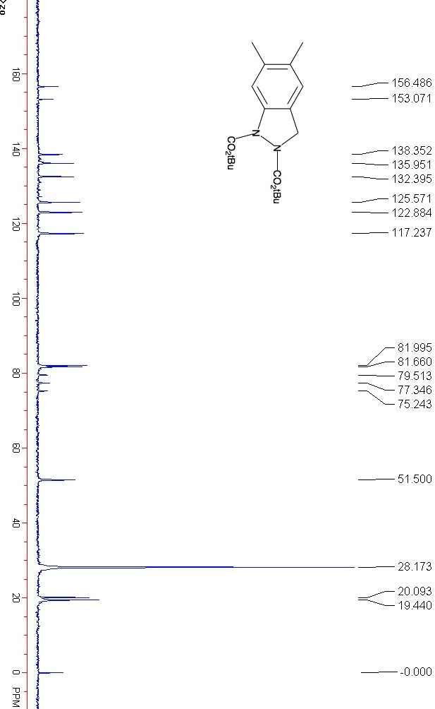

11. ¹H NMR spectrum of 1,2-di-tert-butyl 5,6-dimethoxy-1H-indazole-1,2-(3H)-dicarboxylate (10e)
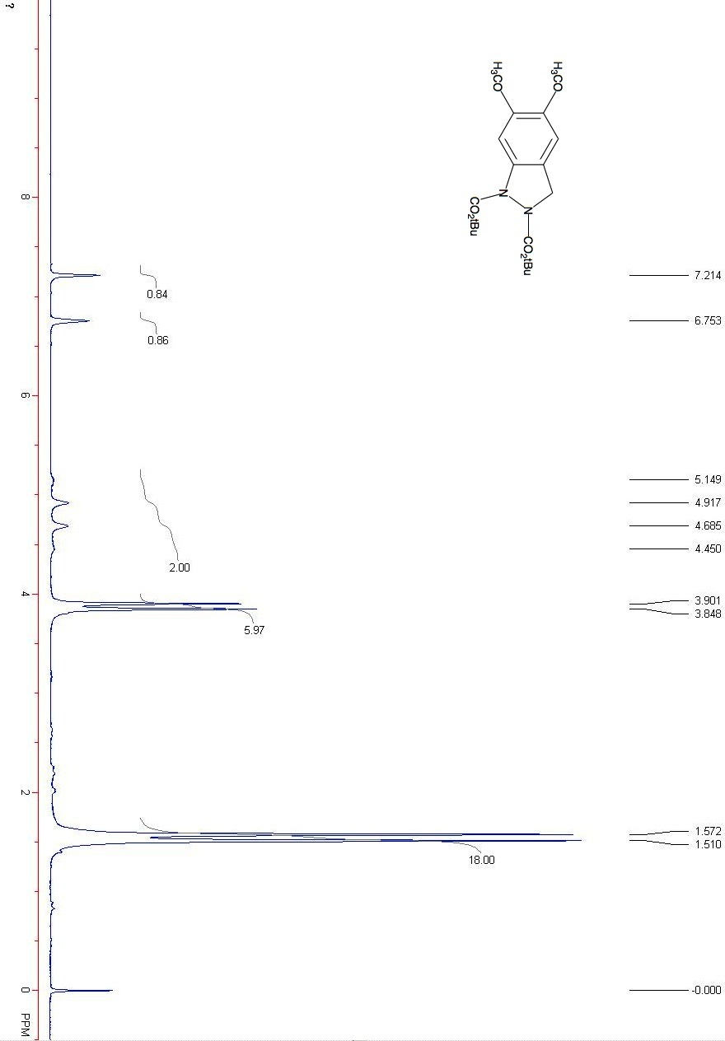

12. ¹³C NMR spectrum of 1,2-di-tert-butyl 5,6-dimethoxy-1H-indazole-1,2-(3H)-dicarboxylate (10e)
